**Research Paper Review**

# **Research Paper - 01:** Smart Irrigation System Technique Using AI and IOT

Accepted on: 04-01-2024

## **Objective:** How we Water Crops by Using Smart Technology Like AI and IOT Or Optimization of Water use in Agriculture

# **Features & Techniques:**

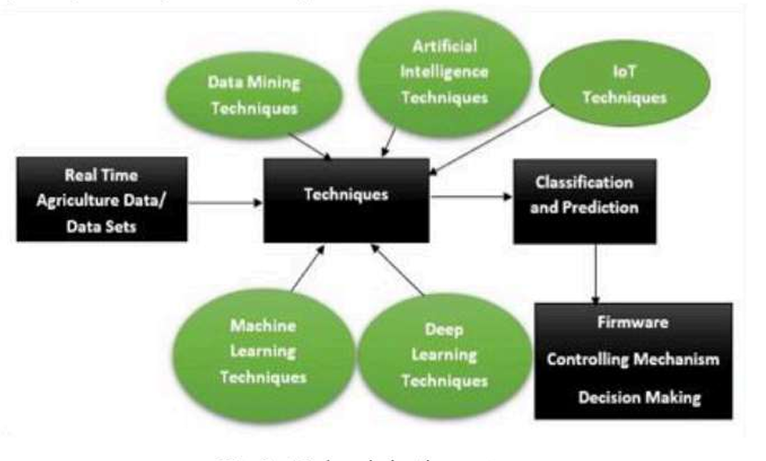

* AI & ML Helps to Decide When and How Much to Water Plants Based on the Condition.
* IOT Device Tracks the Real-time Data from the Soil.
* The System Automatically Waters the Plants When Needed.

# **Formula Discussed for Smart Irrigation:**

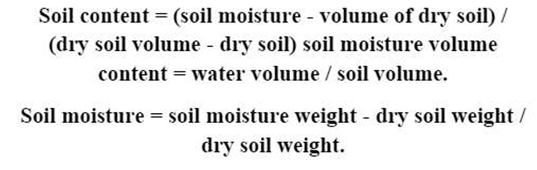

# **Various Technology Discussed:**

1. Raspberry pi, Wi-fi Nodes and Microcontroller – Control Water Pipe.
2. MQTT – Transmit Predictive Data.
3. MCU-12E – Movement of Water Pump (Based on Humidity).
4. M2M Model – Manages the irrigation of Sprinkles.
5. ATMega 328 – Monitor the Level of Sprinkles.
6. Web-GUI & Microcontroller – Mobile Application.
7. ZigBee – For Receiving an Alert.
8. 1185 Sun Rom Color Sensor, ARM7LPC2138 Processor, Solenoid Values and UART - Checking 3 Major Macronutrients: Potassium(K), phosphorous(P), and nitrogen(N) in Soil.

# **Research Paper - 02:** Automated Irrigation System Using AI

Accepted on: 05-05-2024

## **Objective:** Efficient and Effectiveness of Water Usage in Agriculture

# **Workflow & Technique:**

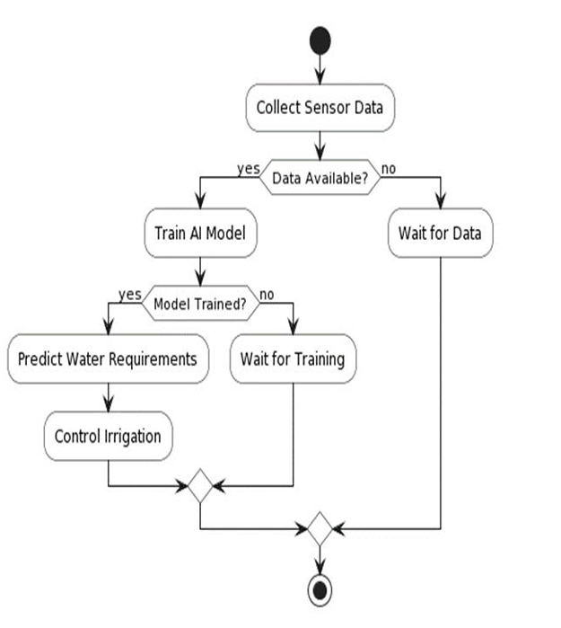

* Collect Real-time data on Soil and Weather Using IOT.
* Analyze the Collected Data with PLSR Algorithm to Determine the Optimal Amount of Water Needed.
* Automatically Controls the Irrigation System Based on Analysis Results.

# **Research Paper - 03:** A Review of Precision Irrigation Water Saving Technology Under Changing Climate for Enhancing Water use Efficiency, Crop Yield, and Environment Footprints.

Accepted on: 05-07-2024

## **Objective:** Improving Water Management, Crop Yield, and Reducing Environment Impact Under Climate Changing

# **Workflow & Features:**

# 

* Focus on Improving Crop Yield to Minimize Environment Footprint.
* Analyze Modernization of Traditional Irrigation method for better Water Efficiency.

# **Technology Used:**

1. AI for Irrigation Scheduling.
2. IOT for Real-time Monitoring and Control.
3. WNS for Data Collection.
4. Decision Support System to Automate Water Management.

# **Research Paper - 04:** Crop Recommendation Using IOT and ML

Accepted on: 02-02-2024

## **Objective:** Efficient Crop Recommendation System Using ML, tailored to Specific Location and Seasons

# **Features:**

1. Use IOT and ML to Gather Data on Soil, Weather, and Crop Conditions.
2. Apply ML Algorithm like Random Forest and LSTM for Recommendation.
3. Provide Real-time insight for Farmers to Optimize Crop Choice.

# **Research Paper - 05:** Water Management in Agriculture: Innovation for Efficient Irrigation

Accepted on: 02-07-2024

## **Objective:** Optimize Water Use and Improve Crop Yield

# **Features:**

1. Use IOT for Real Time Monitoring.
2. Automation and Smart Controllers.
3. Implement Site Specific Water Application Using VRI (Variable Rate Irrigation) techniques and Sensor Based Irrigation Management.
4. Use Automated Valves, Pumps and Cloud Based Platform for Remote Monitoring and Regulation of Irrigation System to Optimize Water Distribution.
5. Use AI & ML for Predicting and Adjusting Water Delivery Based on Crop Growth Pattern, Weather and Historical Data.

# 